Project Description!

On Github we did the project description and in the project description we were explaining how our project benefits the AI community for example with AI the computer is able to identify the differences between plastic and bioplastic and it can tell that the computer is a useful resource to detect materials. People should use this project to identify what is plastic and plastic and what are the physical differences between those 2. We also added our graph here is the link for it: <https://colab.research.google.com/drive/18cQGmeEosJrkXD-QGAS_IOVS61yDz9lH#scrollTo=pCqJk-BjgrkA>.

We also added some information about the project and why is it useful and beneficial for the AI community. The often-cited advantages of bioplastics are reduced use of fossil fuel resources, less pollution, less global warming, and an eco-friendlier world. With our project it will help people recognize that plastic is harmful for animals especially marine life and it will tell people the advantages when using bioplastic for example: bioplastic is less resistant to water that way it doesn’t get washed by the Sea and harm the marine life. One time we saw a turtle which couldn’t swim and can you guess why? because it ate plastic! If animals it plastic they will feel full but they could actually die due to starvation because animals need all the vitamins and nutrition to stay alive and also if they eat plastic, they won’t be able to swim because the plastic get stuck in their stomach which will make it hard for the animals to swim. So, the reason behind this project is so that people will understand that computers are a reliable source to detect various materials and that our project will tell them that plastic is very harmful for animals and even humans because plastic contains chemical, bioplastic is a lot safer for an eco-friendlier environment. If an animals eat plastic, it will eventually die and then when humans eat the animal that first ate plastic humans will feel full and then they will eventually die too because of starvation like I said humans need nutrition and vitamins to stay alive and healthy without them they will eventually die.

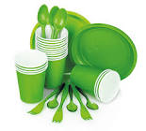

Problem Statement:

What is the problem that the computer will face??

Well, you chose the right team! The answer is that the computer will identify which is plastic and bioplastic, what are the differences between them and which one is better.

With the help of AI the computer will be able to solve that problem statement. The developer of AI could enable many advances, while hamper others. Without AI the computer won’t be able to understand the different algorithms, codes and variables. So, if the computer is not able to solve those 3 important things it will not be able to solve any problem that blocks its way.

Bottom of Form

Methodology:

On the methodology we first wrote the steps on how we accomplished our project for example: we first discussed about the information we are going to be putting in, we then made a summary about our project, we took the summary and put all the information into Google Slides, then we made some changes and checked if we left out any information, we discussed and did the methodology, project description, references and finally the Data Description.

Then I uploaded a graph about the plastic and bioplastic. We also created a summary about the steps we did in a poster I almost forgot that we included Datasets: Bioplastics do produce significantly fewer greenhouse gas emissions than traditional plastics over their lifetime.  
There is no net increase in carbon dioxide when they break down because the plants that bioplastics are made from absorbed that same amount of carbon dioxide as they grew.  
Bioplastic biodegrades/decomposes quicker than normal plastic.

To be honest the hardest part was the graph!

In the methodology we did face a few problems like how to make a graph. Etc. We made the graph on google Collaboratory and we used a video to make it. Overall, the methodology was the most fun part because we learned how to make a graph and we created a mini poster.

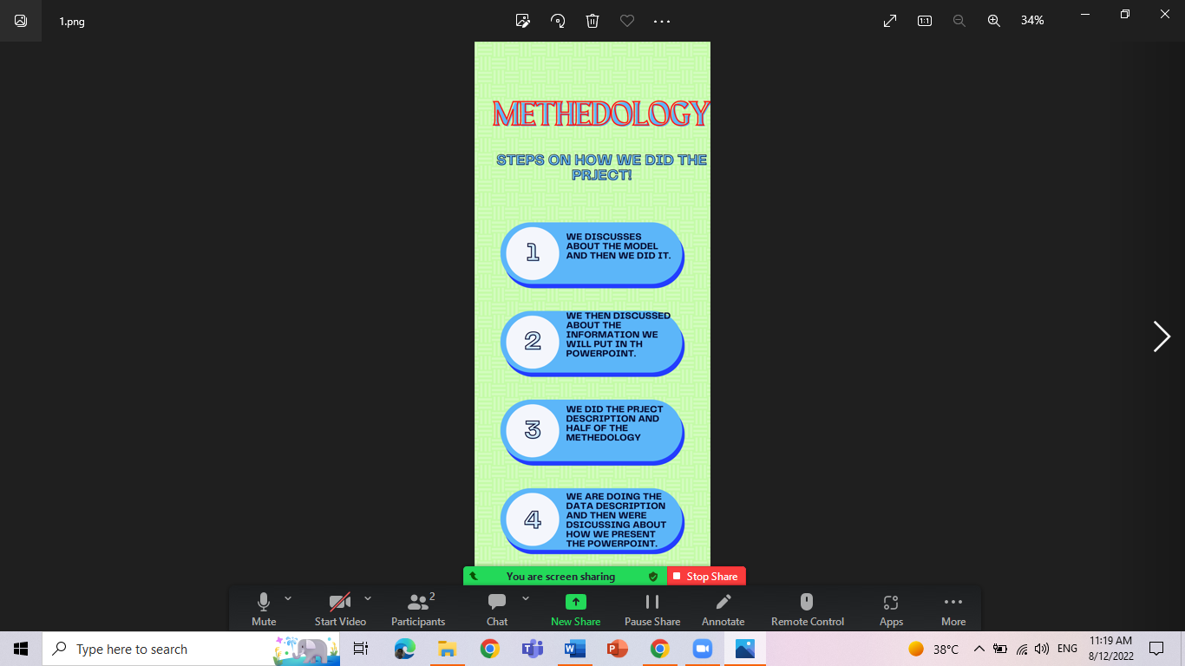

References:

Honestly this part was the easiest because all you had to do was to put the websites that helped you for your project into Github.

Here are the links that gave us some information for our project:

<https://www.biopak.com/sg/resources/bioplastic-vs-regular-plastic#:~:text=Conventional%20plastics%2C%20such%20as%20fossil,%2C%20recycled%20food%20waste%2C%20etc>.

<https://www.bpf.co.uk/plastipedia/how-is-plastic-made.aspx#:~:text=Plastics%20are%20high%20molecular%20weight,silicone%20hydrogel%20for%20optical%20lenses>.

<https://news.climate.columbia.edu/2017/12/13/the-truth-about-bioplastics/#:~:text=The%20often%2Dcited%20advantages%20of,often%20found%20in%20traditional%20plastics>.

Top of Form

Bottom of Form

Data Description!

The 20 images of plastic are for testing.

The 20 images for bioplastic are training

The 10 images from plastic and bioplastic are for testing and the remaining 10 for plastic and bioplastic are for training.

What are the differences between those 2? Plastic is made of chemicals which could harm us while bioplastic are made from some ingredients and materials they don’t have chemicals inside them which is safe for both humans and animals.

Here is the link for an app that we created: <http://ai2.appinventor.mit.edu/#5141679515238400>

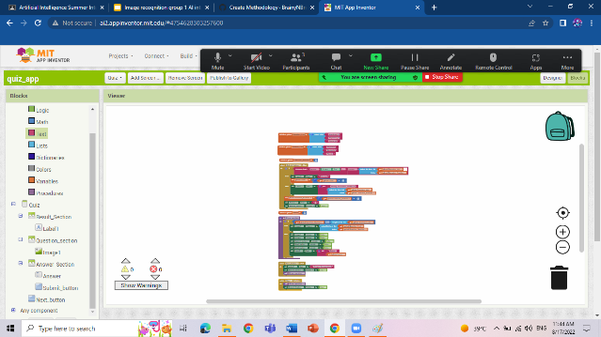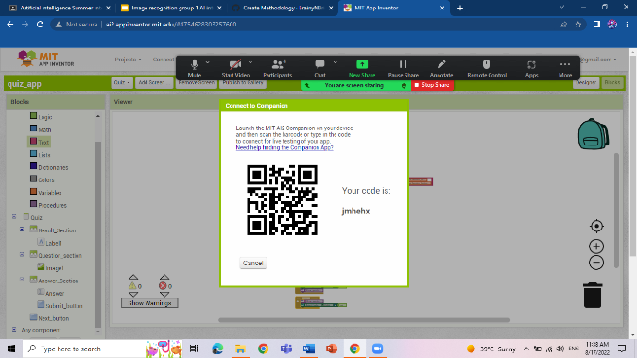

The End!!

Credits to: Rayyan Farrukh, Aayrah Rais and Abhirami Santhosh.

We hope you have learnt something and enjoyed our project!

